# Sentiment Analysis of Central Bank Monetary Policy Communication

## Data

Our dataset comprises a collection of speeches from the institutional website of each central bank. Generally, speeches can vary in their format, depending on the event at which the speech is delivered. The most original contribution of our paper is the evaluation of time varying connectedness and spillover effects of sentiment indices. We find that the Fed influences the other Central Banks for the whole period of analysis, with an increasing magnitude after the Great Recession, proving its “leading role”. After the European debt crisis, the ECB increased its relevance, whereas the BoE gradually reduced it. Finally, the BoJ seems to have a lower impact on other central banks’ communication.

**Pre-processing**

After having prepared the dataset with raw data in *.txt* format, we apply a set of text mining techniques following the literature in the field of NLP (Silge and Robinson, 2017). Such transformations are necessary to process the documents. In detail, the raw data are converted in a text-corpus. We clean the text by converting it to lowercase and then removing numbers, extra spaces, punctuation and regular expressions. A stemming algorithm is also applied to eliminate common suffixes and prefixes. Finally, we tokenize the text, that is, the text is categorized in blocks readable by the software. After this pre-processing phase, we achieve a document-term matrix, which is used to calculate the indicator.

In Figures 2-5 we show the CBSIs time series and highlight both global and country-specific events, such as the Great Recession and the beginning of the Covid-19 crisis (dotted lines) and the European Debt Crisis (shaded area). In Table 2 we provide some summary statistics over the sample period (2008-2021) and for two different subsamples, namely the period of the crisis (2008-2010), the subsequent decade (2011-2019), and the COVID-19 period (2020-2021).

Table 2. Composition of our dataset

|  |  |  |  |  |
| --- | --- | --- | --- | --- |
|  | Fed | ECB | BoE | BoJ |
| Total | 237 | 478 | 123 | 228 |
| Yearly average | 19 | 30 | 9 | 16 |

It is possible that there is a structural break in the time-series caused by the Great Recession and the relative Financial Crisis; indeed, even for the following period (2011-2019) the CBSIs’ averages are considerably lower than for the period 2000-2007. Only the average for the BoJ’s index is higher after the crisis.

This finding could signal a permanent change in communication by central banks: the financial crisis might have induced them to become more cautious when communicating with the public. Releases and speeches are in effect less positive in their content. Moreover, it is important to consider that the recovery from the Great Recession was not synchronized among economic areas, with the Eurozone struggling more than the other countries to return to pre-crisis growth levels. This fact might have contributed to the higher negative impact on ECB sentiment vis-`a-vis other CBSIs. Despite a lower indicator on average than at the beginning of the period of analysis, the CBSIs improved after the crisis. In particular, the Federal Reserve reached its lowest point in sentiment in 2008 (-0.55), but then sentiment steadily increased in the 2010s. In addition, for the BoE and the BoJ the CBSIs improved during the period of economic recovery, although Brexit affected the BoE. This is not the case for the ECB. Indeed, ECB’s average CBSI over the period 2011-2019 is even lower than the average for the period 2008-2010. This might be due to the European debt crisis that characterized the years from 2010 to 2015. Finally, it is remarkable the dramatic drop in sentiment for all Central Banks in 2020 following the worldwide spread of the Covid-19 crisis. In particular, ECB’s sentiment reached its historical minimum in April 2020 (-0.52).

## Introduction

Central bank communication has evolved over the years as an important component of monetary policy design and execution. According to Blinder et al., (2008), central bank communication refers to the quantity and quality of information made available to the public regarding the central bank’s monetary policy objectives and strategy; and its perception on economic outlook as well as signals about future policy trajectory. Thus, the development of appropriate communication strategies has become popular among central banks, especially as a means of shaping market expectations. As argued by Coenen et al., (2017), the increased popularity of central bank communication derives from the need for greater monetary policy transparency as a strategic requirement for an inflation targeting monetary policy framework.

Naghdaliyev (2011) argued that the need to effectively manage expectations constitutes one of the key policy challenges of the post 2008 global financial crisis. He further emphasized that the provision of appropriate information to the public about central bank policy actions helps reduce rather than exacerbate economic uncertainties, thus making central bank communication a primary tool for expectations management.

*Figure 1: Central bank’s objectives communication*

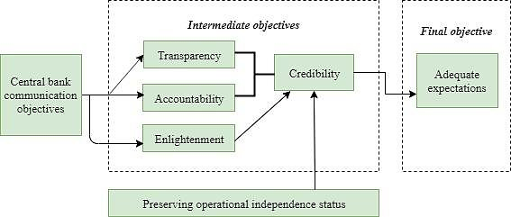

Source: Naghdaliyev (2011)

While the final objective relates to the effective management of expectations, the intermediate objectives of central bank communication should necessarily encompass transparency, accountability, and credibility (Figure 1). Of the three intermediate objectives, Naghdaliyev (2011) states that credibility is the most crucial, noting that the ability of the central bank to adequately shape expectations rests on its credibility. Thus, the crucial link between central bank communication and central bank credibility represents one of the reasons why communication has become an important aspect of monetary policy.

Several channels are usually adopted for communication, including but not limited to monetary policy reports, minutes of monetary policy meetings, post-meeting briefings by central bank Governors and speeches by Monetary Policy Committee (MPC) members. Recognizing the crucial roles of central bank communication in monetary policy effectiveness, many central banks have developed communication strategies to systematically disseminate their policy objectives and decisions to the public. For instance, the Governing Council of the European Central Bank holds its monetary policy meeting every six weeks, with the ECB President conducting a press conference after each meeting to explain its monetary policy decisions from a prepared statement, similarly the FOMC (of the Federal Reserve -FED-) holds eight regularly scheduled meetings per year. At these meetings, the Committee reviews economic and financial conditions, determines the appropriate stance of monetary policy, and assesses the risks to its long-run goals of price stability and sustainable economic growth.

Different methods are available for the analysis of central bank communication; including the indirect approach (whereby financial market reactions to policy announcements are measured using event windows), and a direct approach (whereby the researcher provides a subjective assessment of central bank communication by manually reading through the policy document and coding its contents into numerical scales). In recent times, the advancement in text mining algorithms provides for a more objective procedure in which the content of many documents is analyzed using a computer-based approach.

The monetary policy documents published by these central banks were analyzed using text mining tools and it was found that concerns relating to financial stability and economic uncertainties were quite high during the crisis. Quite a number of studies have examined the relationship between central bank communication and macroeconomic out-turns. For instance, Shapiro and Wilson (2019) applied text mining techniques to analyze the transcripts of the FOMC meetings, the minutes of their meetings as well as speeches of FOMC members for the period 1986-2013. They extracted a measure of monetary policy sentiment from the group of documents considered and showed that FOMC’s negative sentiments were inversely related to United States’ output growth.

We contribute to the empirical literature along several dimensions. Following Loughran and McDonald (2011), we construct our own Central Bank Sentiment Indexes (CBSI), applying text analysis to a novel dataset that comprises releases and speeches published by the Federal Reserve (Fed), the European Central Bank (ECB), the Bank of England (BoE) and the Bank of Japan (BoJ) between 2008 and 2020. In addition, we create word clouds for the fifty most important words for each central bank using the Terms Frequency-Inverse Document Frequency function (Tf-Idf).

*Figure 2. Governor’s and MPC speeches*

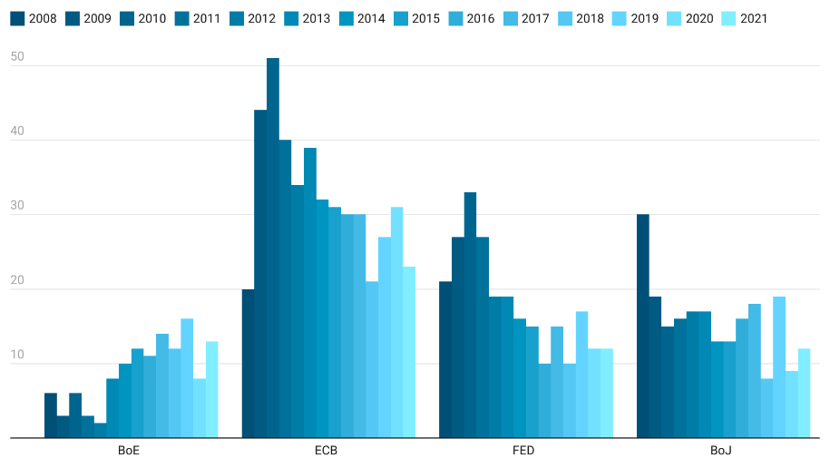

Having processed the textual data into a form suitable for analysis, we examined the readability, and sentiments of the policy documents. While the central banks communication has decreased over the years, suggesting that monetary policy transparency has not increased over the years. In addition, our results indicate that the words and terms driving the linguistic contents of the communiques were influenced by the Bank’s policy objectives as well as the nature of shocks hitting the economy.

## Construction of the Sentiment Analysis index

The aim of this section is to build and analyze a sentiment analysis model which will allow us to categorize monetary authorities based on their sentiments, that is whether they are positive, negative and also the magnitude of it.

This section employs text-mining techniques to analyze the communication strategy of the four world most important central banks during the period 2008-2021. Since the policy communique released after each meeting of the monetary policy committee (MPC) represents an important tool of central banks communication, we construct a corpus based on 1,066 policy communiques: Bank of England (123), Federal Reserve (237), European Central Bank (478) and Bank of Japan (228).

In order to see if the texts may contain some useful insight to predict the Central Banks interest rate, we use the Loughran and McDonald Sentiment Word List[1] to measure the sentiment of statement. This dictionary contains several thousand words appearing in textual analysis in accounting and financial documents such as 10K, 10Q. It includes words in different forms, so stemming or lemmatizing should not be applied. We applied a simply technique to flip the sentiment for negation (e.g., can’t, isn’t, no).

The opinions, and affective states of people reflected in a corpus of textual data can be based on sentiment analysis. Basically, the procedure for sentiment analysis involves categorizing the opinion expressed in a document as positive, neutral, or negative. We apply this technique to our data set in order to study the evolution of monetary policy sentiments as expressed in the policy communiques. The monetary policy sentiment score summarizes the perception of the MPC regarding the upside and downside risks to the achievement of each Central Bank’s policy objectives.

Following the approach in Binette and Tchebotarev (2019), the CBN’s monetary policy net sentiment score (MPSS) for each document in our corpus is derived as:

(1)

Where 𝑁𝑝𝑜𝑠𝑡𝑖𝑣𝑒 denotes the number of words expressing positive sentiments, 𝑁𝑛𝑒𝑔𝑎𝑡𝑖𝑣𝑒 is the number of words expressing negative sentiments, and *NT𝑜𝑡𝑎𝑙* is the total number of words in the document. Any positive sentiment term used in a document takes the value superior than 1 while a negative sentiment term takes a value inferior to -1. It is implied in Eq. (1) that a value of MPSS > 0 indicates positive sentiments while MPSS < 0 signifies the expression of negative sentiments. The computed MPSS enables us to derive useful insights regarding the Central Bank’s perception on the direction of change in economic conditions.

## Results of Sentiment Analysis

In Figures 3 and 4, we show the plot of the computed monetary policy net sentiment score (MPSS) for the period 2008 – 2021. The global average MPSS for the period was of 0.0496, implying that the MPC was inundated by policy uncertainties generated by various global and domestic economic shocks during the sample period.

*Table 1. Sentiment Analysis index: average*

|  |  |  |  |  |
| --- | --- | --- | --- | --- |
| ***Central Bank*** | ***Global MPSS*** | ***Governors’ MPSS*** | | |
| Bank of England | -0.1109 | *M. King:*  -1.323 | *M. Carney:*  0.206 | *A. Bailey:*  0.015 |
| European Central Bank | 0.3368 | *J.C. Trichet:*  0.141 | *M. Draghi*:  0.536 | *Ch. Lagarde:*  -0.001 |
| Federal Reserve | -0.1496 | *B. Bernanke:*  -0.377 | *J. Yellen*:  0.181 | *J. Powell:*  0.151 |
| Bank of Japan | 0.1224 | *T. Fukui:*  0.752 | *M. Shirakawa:*  -0.502 | *H. Kuroda:*  0.553 |

Our results show that the FED’s policy statements have recorded less optimistic tone and more certainty to the negative impact of crisis and economic phenomenon, while the tones of the policy statements published by the ECB and Bank of Japan (BoJ) have remained unchanged and with a more optimistic tone. Being Sir. King the lest optimistic governor (although it is important to measure the speeches number of 23), while the most optimist was Mr. Draghi.

**Sentiment analysis and growth**

As shown in Figure 3, the issues relating to the impacts of economic shocks on each economy has remained an important source of concern to the monetary authorities, for example we can show different peaks in the sample, in the first quarter of 2009 the FED, reached the most negative sentiment peak, while the BoE recorded its negative peaks in the second semester of 2016 during the economic recession; while the BoJ recorded its most negative peak during the last quarter of 2008, and finally, the ECB showed its one during the second quarter of 2009.

Our sentiment indicators, mimic the general path of economic performance for each country economy. The lowest points of the sentiment index also coincide with the deteriorating economic outlook during the main economic recessions of the past two decades.

For instance, the dip in the MPSS reflects the great recession (hat occurred between 2007 and 2009). For example, the lowest BoE’s MPSS, which was recorded in July 2016 reflects the MPC’s perception regarding the potential risks to the attainment of its policy objectives with respect to interest rates, and economic growth, which was of 0.44%.

On the other hand, the BoE’s MPSS record two peaks in the first quarter of 2016, and in the second quarter of 2019 with the MPC expressing its satisfaction about the performance of the economy, especially with regards to economic growth (of 0.54%). While the BoJ peaked in the third quarter of 2016, the Fed show its peak in the last quarter of 2016, last the ECB recorded its peak one year later, at the end of 2017.

**Figure 3. Economic growth and the sentiment index**

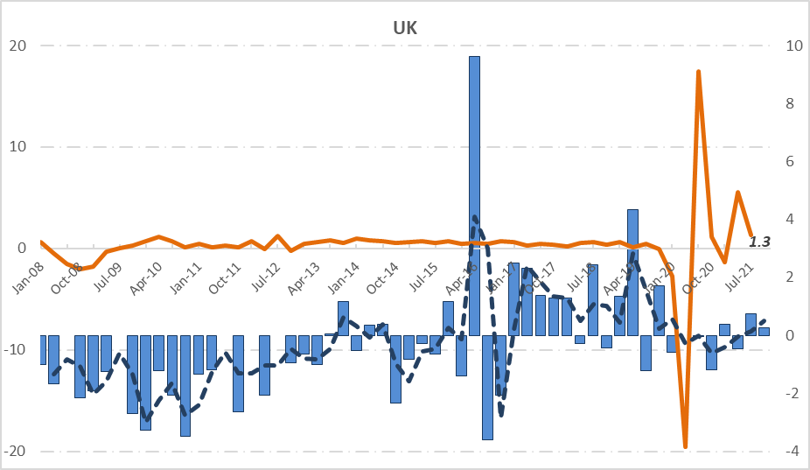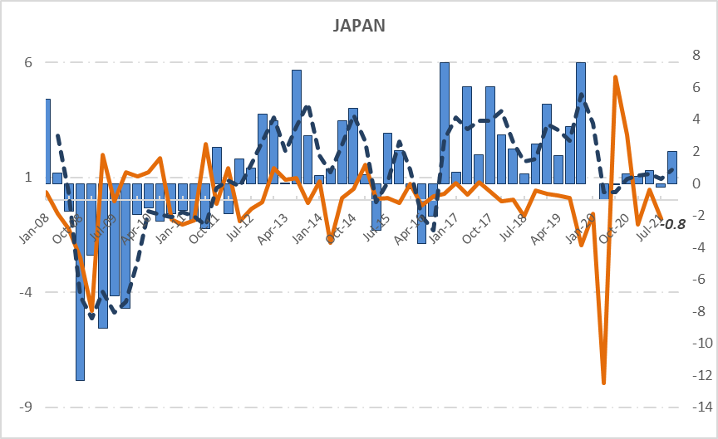

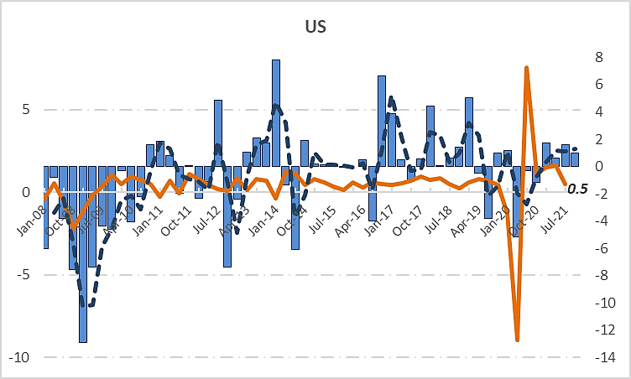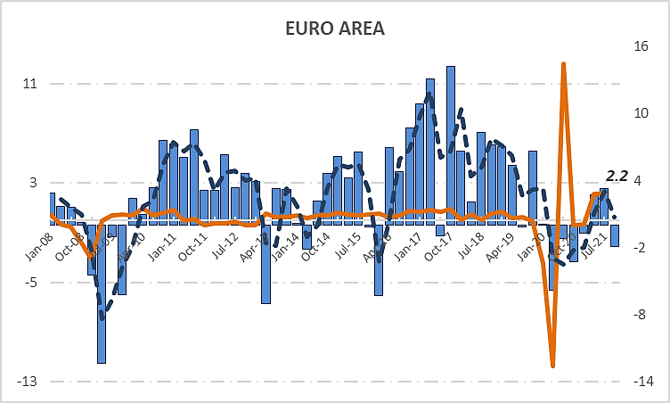

Note. – In the left x-axis the quarterly economic growth rate (in orange) and in the right x-axis, the quarterly sentiment index (in blue), the dashed line represents its moving average (dark blue).

**The MPSS during the Covid-19**

Despite the economy’s exit from recession beginning in 2017, the MPC expressed substantial negative sentiments in January 2019. The negative MPSS recorded during this period was due to global economic uncertainties and the declining oil prices.

On the domestic front, the resurgence of moderate inflationary pressure and possible threats to accretion to external reserves due to softening crude oil prices were noted”. While this study is not aimed at providing a detailed analysis of the evolution of the MPSS over the sample period, we note that subsequent effort can pursue this area of research further.

**Comparison between Central Banks**

Sentiment analysis of CBN’s communications yields an overview of the tonal development of Central Banks’ messages over time. In this section, we survey the developmental trajectory of the interest rate and monetary policy sentiments in the speeches. Developments in the economic condition sentiment index during the 2008-2021 period reveals significant differences between countries.

Hence, for descriptive purposes, we minimize these sentiment index disturbances by using a specific number of moving averages for each country due to the extension of each individual database. Second, our methodological approach to calculating the sentiment index do not differ between lexicons. Thus, one should compare sentiment index trends and raw absolute numbers too. Also, each plot indicates the date when the interest rate changed due to introduction of central banks purchases longer-term securities.

**Figure 3.1 BoE: Sentiment analysis evolution**

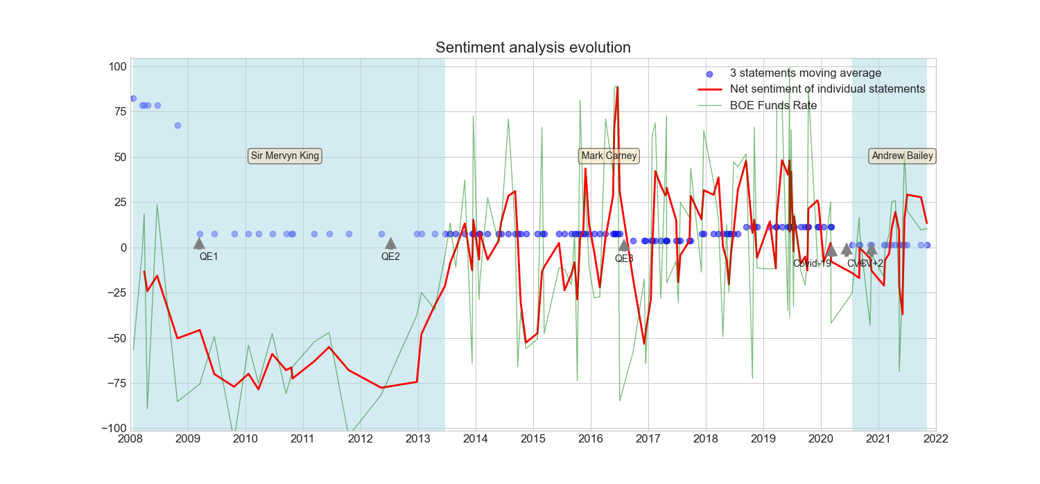

For example, in the Figure 3.1 we can see that the economic sentiment in BoE communications were pessimist during 2008 and mid-2013, although its tone improved later, in line with the recovery of the euro area in the aftermath of the financial crisis, from 2014 until mid-2019 swaying, with the appearance of Covid-19 the index starts a decline phase until the beginning of 2021.

The ECB’s economic sentiment presented a deterioration from 2008 and recovered slightly until mid-2011, after that it showed a constant negative trend registering dips in 2013 and the first quarter of 2016 with the onset of the euro-area financial/debt crisis. The ECB announced a significant downward forecast revision in their press conferences in November 2011. The negative economic outlook during the euro area crisis culminated in mid-2016. In 2017, the economic sentiment started gradually improving again, in line with the onset of the euro area’s economic recovery until the appearance of Covid-19, the index faced a dip decline in 2020.

**Figure 3.2 ECB: Sentiment analysis evolution**

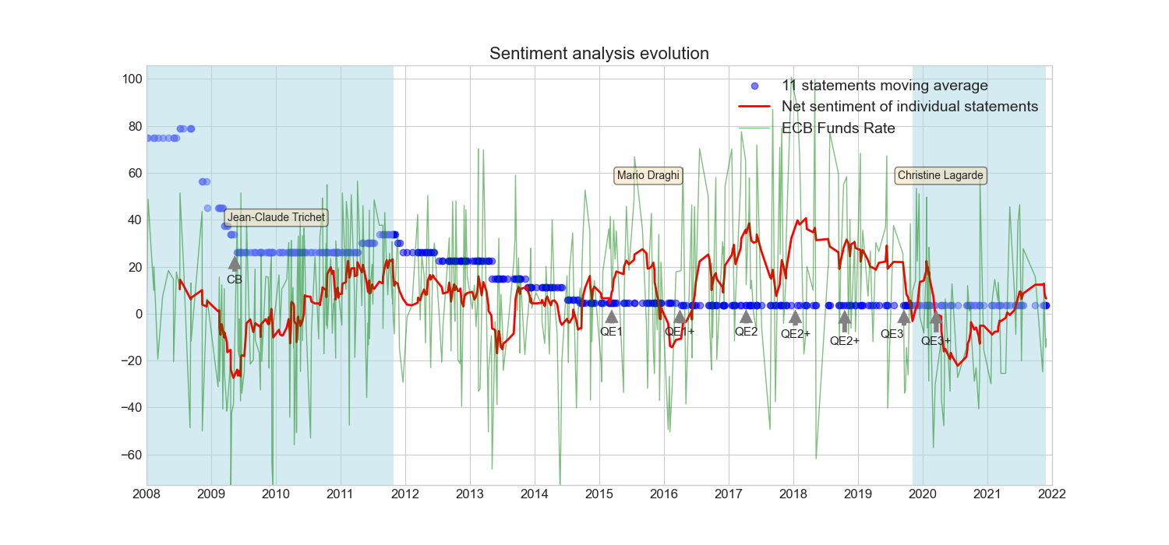

**Figure 3.3 Fed: Sentiment analysis evolution**

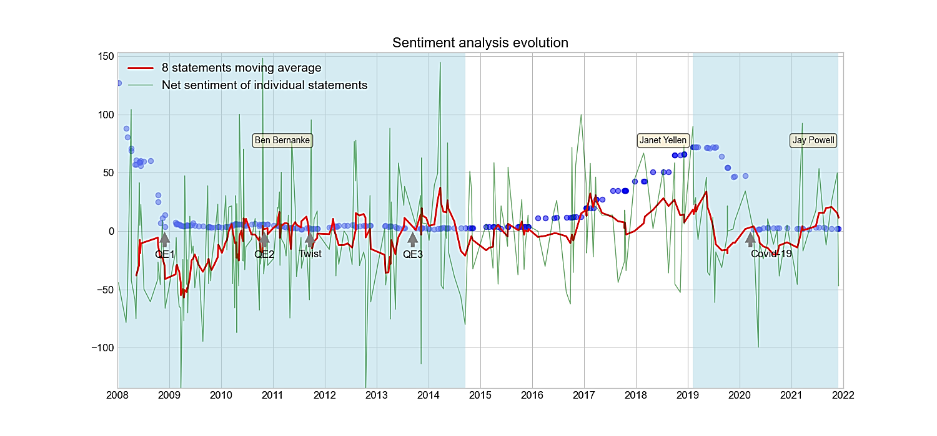

On the other hand, for the Fed, Figure 3.3 shows similar developments in the monetary policy sentiment index over the past decade and a half, its evolution shows a similar pattern, with the only difference of the absence of the 2016 dip, regarding the Covid-19, the sentiment index declined in the first quarter of 2019[2]. Finally, the evolution of the index for the BoJ, it shows a negative sentiment during 2008 until 2012, its negative dip was registered at the beginnings of 2009, after 2013, it showed a stable path, and even it shows a more positive tone from 2018 until the appearance of Covid-19, where it followed a negative trend, it doesn’t seem to recover an optimistic tone for the following months.

**Figure 3.4 BoJ: Sentiment analysis evolution**

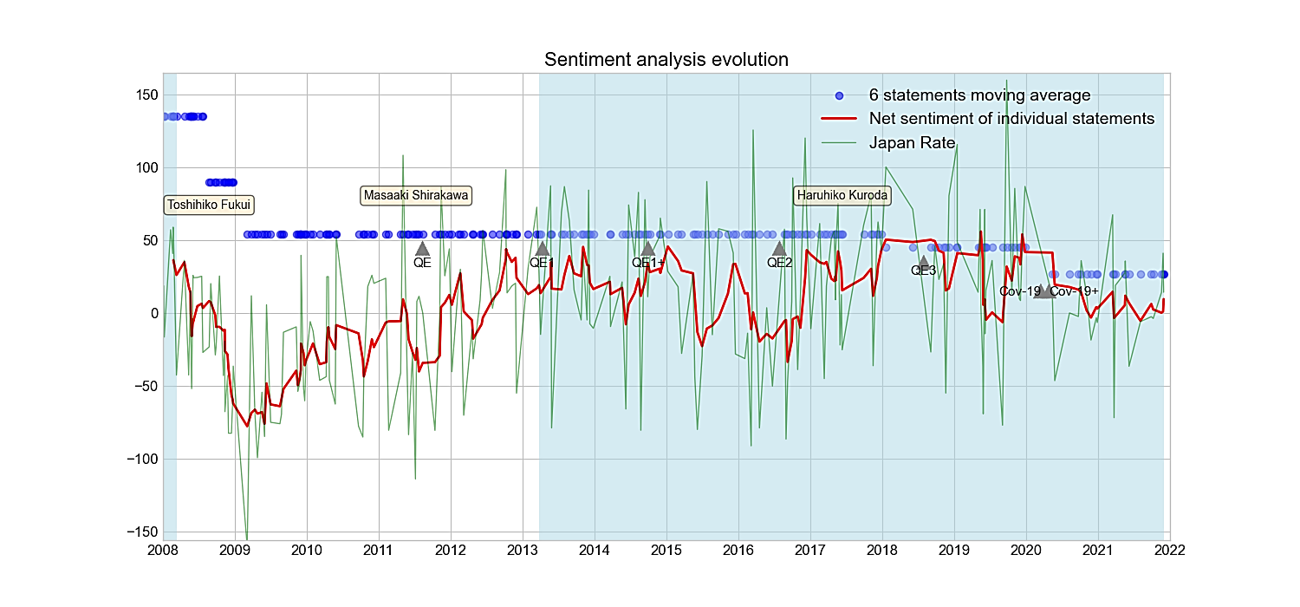

A positive shock to Central Bank communication seems to have a positive and significant impact on the interest rate, but negative on the yield curve slope (consistently with Armelius et al., 2020). The Central Banks’ sentiment indexes appear to be connected (with the sole exception of BoE and BoJ) and the most relevant spillovers are between the Fed and the ECB.

**EDA**

As earlier noted, the Nigerian economy got into a recession in 2016 driven largely by negative oil price shocks as well as other developments in the global economy. For instance, the second paragraph of Communique No. 107 (May 2016) reads “…The Committee noted with concern, the tapered growth and continued decline in global output since 2014. At an estimated 3.2 per cent, global output in 2016 was only 0.1 percentage point below the 3.1 per cent in the corresponding period of 2015. The sluggish global output was traced to weak fundamentals in both the advanced economies and Emerging Markets and Developing Economies (EMDEs), including increased volatility in global financial markets, sustained softness in commodity prices, sluggish global trade, resulting in persistent fragility, particularly in the EMDEs”. Expectedly, the topic proportion relating to economic growth increased substantially during 2015 and the first half of 2016 after which the GDP growth reached its trough and recorded an inflexion. It is also important to note that the topic proportion relating to exchange rate management and exchange rate pass-through to domestic prices increased during 2016 -2017, reflecting the foreign exchange market pressures of 2015 and the exchange rate reforms implemented in June 2016. Consequently, the MPR was increased in the July 2016 meeting of the monetary policy committee.

1. **The Taylor rules**

In the case of the Bank of Japan (BOJ), Luangaram and Sethapramote (2016) augmented the standard Taylor-type rule specifications with text-based indicators generated from the BOJ’s monetary policy reports. Their results also showed that the computed indicators improved the performance of the Taylor-type rule specifications in predicting future policy interest rate in Japan. Similar findings were obtained by Park et al. (2019) for the Bank of Korea (BOK) and Demiralp et al. (2012) for the Central Bank of Turkey (CBRT).

Also, Sturm and De Haan (2011) investigated the usefulness of ECB’s communication in enhancing monetary policy prediction within the framework of an augmented Taylor rule model. They applied text mining techniques on the statements issued by the ECB President at the end of each ECB policy meeting and showed that the text-based indicators derived from the ECB communication provided additional information for predicting the Banks future policy decisions.

**REFERENCES**

1. Armelius, H., C. Bertsch, I. Hull, and X. Zhang (2020). “Spread the word: International spillovers from central bank communication”. Journal of International Money and Finance 103, 102116.
2. Binette, A. and Tchebotarev, D. (2019). Canada’s Monetary Policy Report: If Text could Speak, what would it Say? Bank of Canada Staff Analytical Note.
3. Blinder, A. S., Ehrmann, M., Fratzscher, M., De Haan, J. and Jansen, D.J. (2008). “Central Bank Communication and Monetary Policy: A Survey of Theory and Evidence”. Journal of Economic Literature. 46(4), 910–945.
4. Coenen, G., Ehrmann, M., Gaballo, G., Hoffmann, P., Nakov, A., Nardelli, S., Persson, E. and Strasser, G. (2017), “Communication of Monetary Policy in Unconventional Times”. ECB Working Paper. No. 2080.
5. Naghdaliyev, N. S. (2011). “Central Banks’ Communication in the Post-crisis Period”. The Harriman Institute, Columbia University.
6. Shapiro, A. H. and Wilson, D. (2019). Taking the Fed at its Word: Direct Estimation of Central Bank Objectives using Text Analytics. Federal Reserve Bank of San Francisco Working Paper 2019-02.
7. Silge, J. and D. Robinson (2017). Text mining with R: A Tidy Approach. O’Reilly Media, Inc.
8. Sturm, J.-E. and De Haan, J. (2011). Does Central Bank Communication Really Lead to Better Forecasts of Policy Decisions? New Evidence Based on a Taylor Rule Model for the ECB. Review of World Economics. 147(1), 41–58.

1. These Loughran and McDonald lexicon makes use of unigrams, unigrams are a type of n-gram model that consists of a sequence of 1 item, that is, a word collected from a given textual data. The Loughran and McDonald model performs an analysis of the shareholder’s reports.
2. In 2019 the real gross domestic product (GDP) of the United States increased by 2.2 percent compared to 2018. This rate of annual growth is around the average for the 2010’s, although much lower than the rates of around three to five percent seen for much of the decade between 1995 and 2005. It is certain that 2020 will see a dramatic decline in the GDP growth rate due to the coronavirus (COVID-19) pandemic. Initial quarterly projections of Real GDP suggest a fall by as much as 30 percent. Our topic analysis shows the following results: unemployment, recession, financial stress, uncertainty, all these topics are before the start of the Covid-19 pandemic.